**Title: rev. 2**

**Checking airtight humidifier container**

**Purpose:**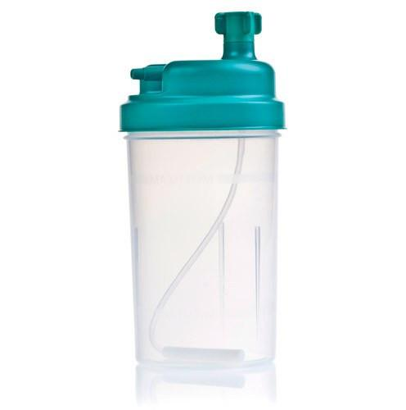

To ensure if there are any leakages in the box.

**Update:**

In this iteration standard medical grade humidifier bottle is used.

**Materials required:t**

1. Humidifier container.
2. Large container (approx or larger than dimensions: 30 x 30 x 15 ; L,W,D, all units in cm)
3. Enough water to fill the large container

**Procedure:**

Close the container lid properly & entirely dip the container to the bottom of the water filled large container for 5 minutes. Check if any bubble is coming out from the container. After 5 minutes, pull the container out & wash the outside area carefully. Then open the lid & check if any water droplets are left inside. A tissue paper can be used to detect water droplets inside the container.

**Results & Conclusion:**

If any water droplets are found inside the container it signifies that there is a leakage in the box & it cannot be used in the CPAP device. If no droplets are found, we can go ahead with the box for further setups.